|  |
| --- |
| **Q. matrix** |
| a=matrix(c(1,2,-2,-1,3,0,0,-2,1),nrow=3,ncol=3,byrow=TRUE)  print(a)  b=matrix(c(1,0,-1,3,4,5,0,-6,-7),nrow=3,ncol=3,byrow=TRUE)  print(b)  #ADD  m=a+b  print(m)  #MULTIPLICATION OF A AND B  p=a*b  print(p)  #TRANSPOSE OF A  n=t(a)  print(n)  #DET OF A  w=det(a)  print(w)  #INVERSE OF A  q=solve(a)  print(q)  #DET OF B  x=det(b)  print(x)  #INVERSE OF B  u=solve(b)  print(u)   |  | | --- | | **Q. A random sample of 33 individuals who listen to talk radio was selected and the hours per week that each listens to talk radio was determined. The data are as follows.**  **9 8 7 4 8 6 8 8 7 10 8 10 6 7 7 8 9**  **6 5 8 5 6 8 7 8 5 5 8 7 6 6 4 5**  **Test the null hypothesis using R that μ = 5 hours (h) versus the alternative hypothesis that μ ≠ 5 at level of significance α = 0.05 in the following three equivalent ways:**  **(a) Compute the value of the test statistic and compare it with the critical value for α = 0.05**  **(b) Compute the p-value corresponding to the computed test statistic and compare the p-value with α = 0.05.**  **(c) Compute the 1 - α = 0.95 confidence interval for μ and determine whether 5 falls in this interval.** |   ANS: a<-c(9,8,7,4,8,6,8,8,7,10,6,7,7,8,9,6,5,8,5,6,7,8,5,5,8,7,6,6,4,5)  n=33  xbar=mean(a)  xbar  pm=5  b=sd(a)  z=((xbar-pm)/(b-sqrt(n))) #z=((xbar-pm)/(sqrt((b^2)/(n-1))))  z  alpha=0.05  z.half.alpha=qt(1-alpha/2,df=n-1)  c(-z.half.alpha,z.half.alpha)  z.alpha=qnorm(1-alpha)  z.alpha  Q**. A car travels 25 miles at 25 miles per hour (mi/h), 25 miles at 50 mph, and 25 miles at 75 mph. Write a program to find the arithmetic mean of the three velocities and the harmonic mean of the three velocities.**  **Which is correct?**  a=mean(c(25,75,50))  print( a)  b=1/mean(1/a))  print(b) |

|  |  |  |
| --- | --- | --- |
| **Enter the following details of wages of 65 employees at the ABC Ltd. In Excel: Wages** | **Number of Employees** |  |
| **25000-25999** | **8** |  |
| **26000-26999** | **10** |  |
| **27000-27999** | **16** |  |
| **28000-28999** | **14** |  |
| **29000-29999** | **10** |  |
| **30000-30999** | **5** |  |
| **31000-31999** | **2** |  |
| **Total**  M=c(8,10,16,14,2,16,10,5,2)  Mean(m)  Median(m)  Getmode=function(m)  Uniqv=unique(m)  Uniqv[which.max(tabulate(match(m,uniqv)))]  R=getmode(m)  Print(r**)** | **65** |  |

**Q. The time spent watching TV per week by middle-school students has a normal distribution with mean 20.5 hours and standard deviation 5.5 hours. Use R to find the percent who watch less than 25 hours per week. Use R to find the percent who watch over 30 hours per week. Sketch a curve representing these two groups using R or Excel**

Ans: x <- seq(-25,30,by=1)

Y<- dnorm(x,mean=20.5,sd=5.5)

Png(file=”normal2.png”)

Plot(x,y)

Dev.off()

Q. **Enter the following data sets in Excel:**

**a) 12, 6, 7, 3, 15, 10, 18, 5**

**b) 9, 3, 8, 8, 9, 8, 9, 18.**

**Import the data in R and find standard deviation and variance of the data sets using R.** 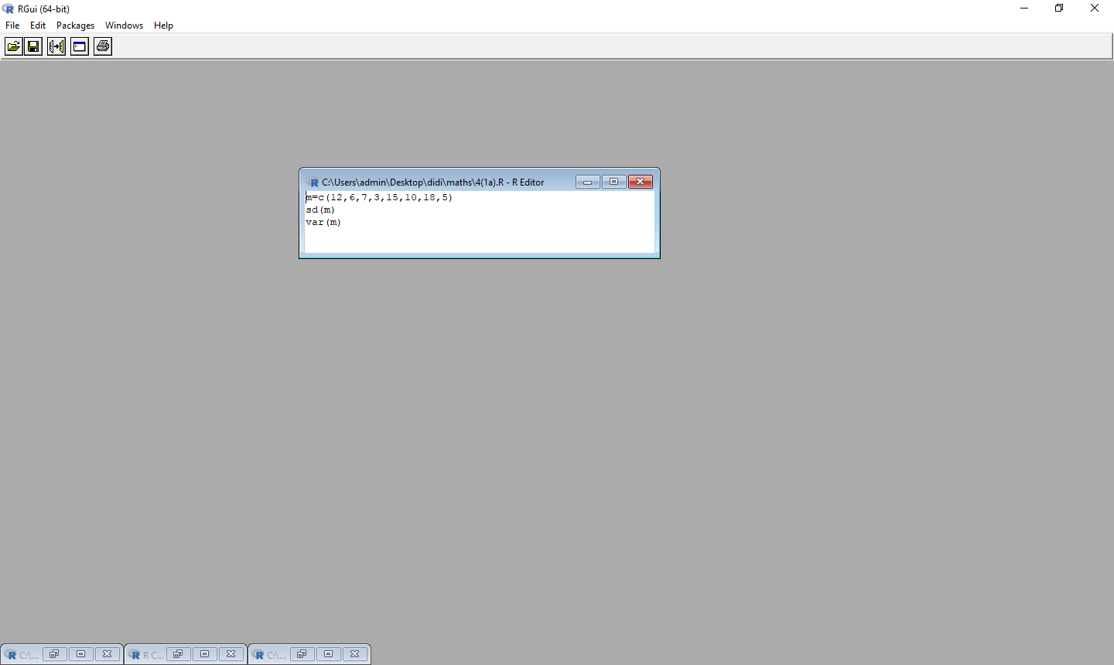

**Q.**

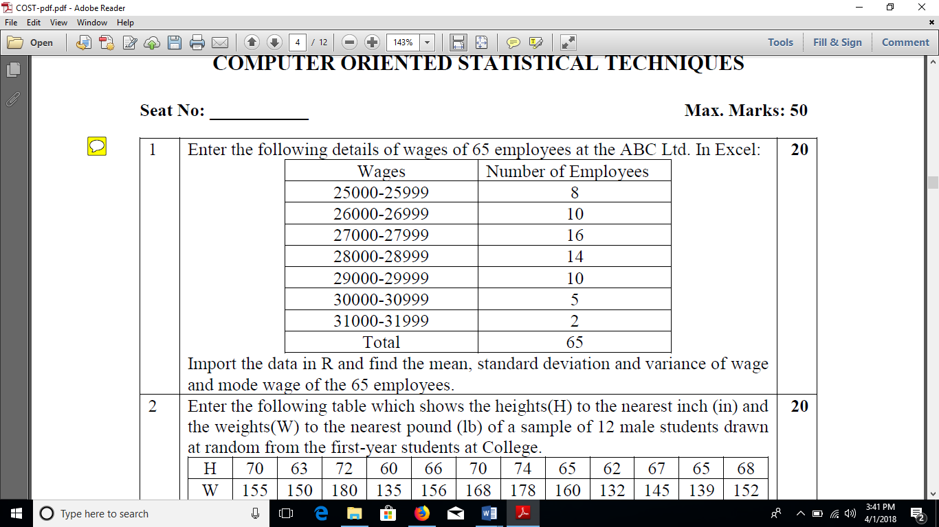

**ANS:**



**Q.**

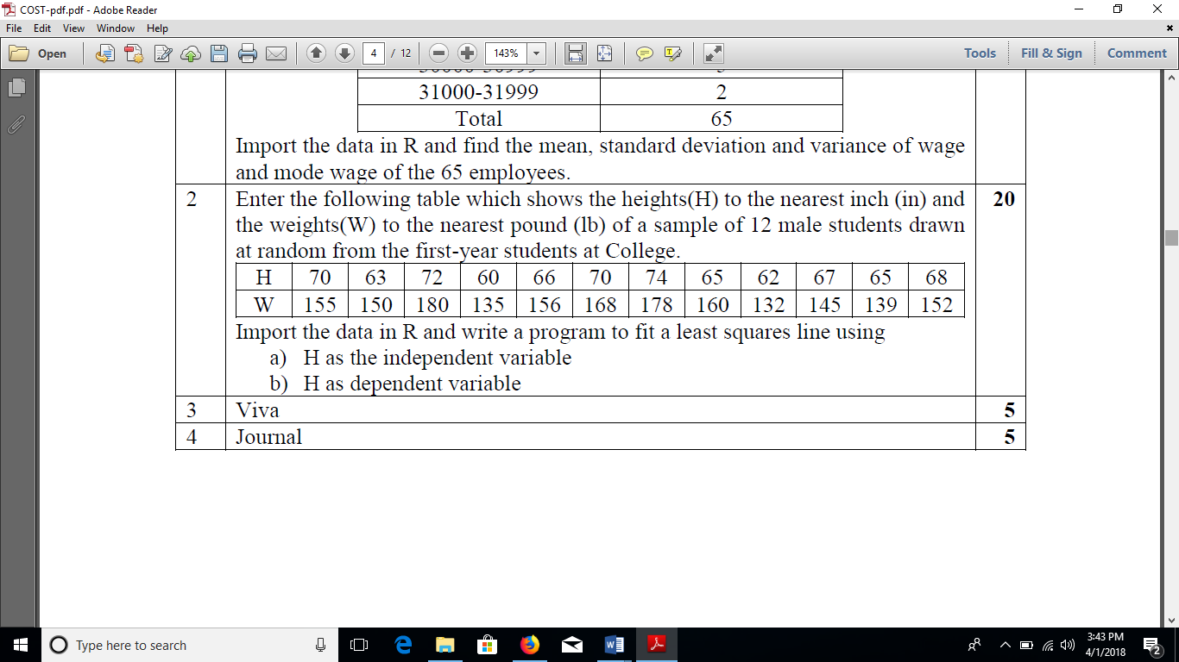

Ans : ***when h is dependant***

n=12

h=c(70,63,72,60,66,70,74,65,62,67,65,68)

w=c(155,150,180,135,156,168,178,160,132,145,139,152)

plot(h,w,main="population",col="blue")

cor(h,w)

fit=lm(w~h)

fit

cat("\n\n")

attributes(fit)

**When h is independent w will come first**

n=12

h=c(70,63,72,60,66,70,74,65,62,67,65,68)

w=c(155,150,180,135,156,168,178,160,132,145,139,152)

plot(w,h,main="population",col="blue")

cor(w,h)

fit=lm(h~w)

fit

cat("\n\n")

attributes(fit)

q.

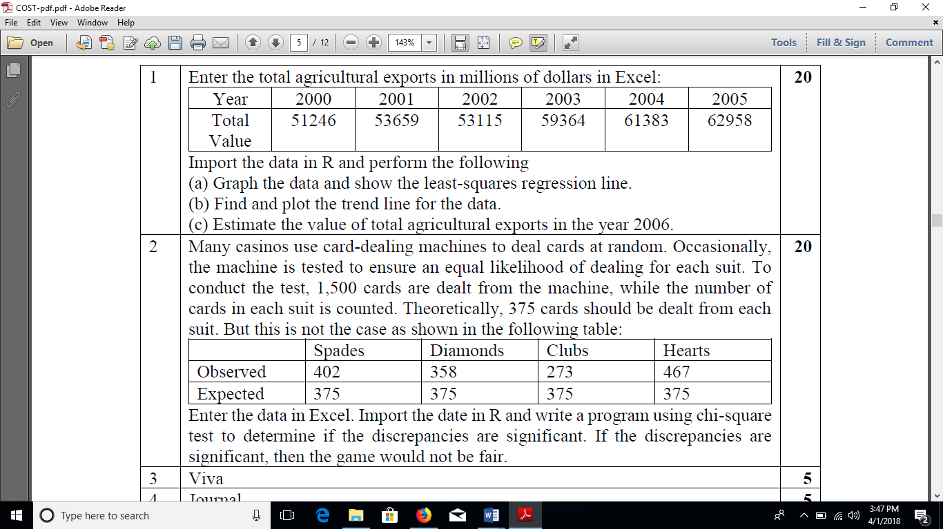

n=6

h=c(2000,2001,2002,2003,2004,2005)

w=c(51246,53659,53115,59364,61383,62958)

plot(h,w,main="population",col="blue")

cor(h,w)

fit=lm(w~h)

fit

cat("\n\n")

attributes(fit)

a=data.frame(h=2006)

r=predict(fit,a)

print (r)

png(file="trend.png")

plot(w,h,col="red",main="trend", abline(lm(w~h)),cex=1.5, pch=16,xlab="year",ylab="turnover")

dev.off()

2.

o=c(402,358,273,467)

e=c(375,375,375,375)

c.data<-data.frame(o,e)

c.data=table(o,e)

print(c.data)

print(chisq.test(c.data))

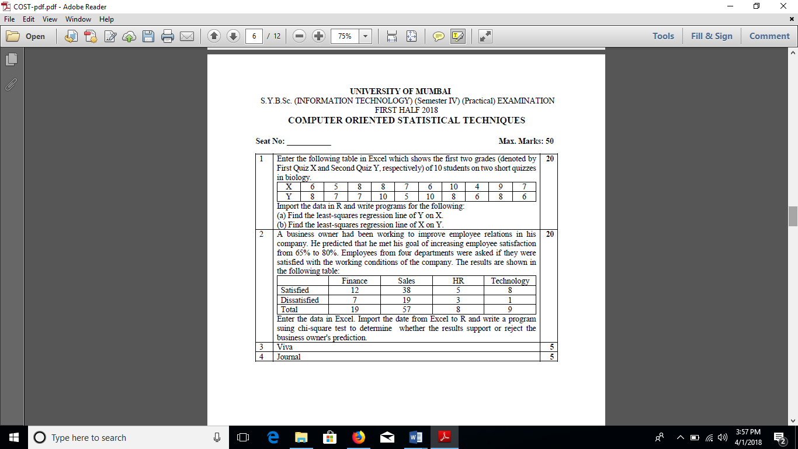

For y on x

n=10

x=c(6,5,8,8,7,6,10,4,9,7)

y=c(8,7,7,10,5,10,8,6,8,6)

plot(y,x,main="population",col="blue")

cor(y,x)

fit=lm(x~y)

fit

cat("\n\n")

attributes(fit)

For x on y

n=10

x=c(6,5,8,8,7,6,10,4,9,7)

y=c(8,7,7,10,5,10,8,6,8,6)

plot(x,y,main="population",col="blue")

cor(x,y)

fit=lm(y~x)

fit

cat("\n\n")

attributes(fit)

2.

S=c(2,38,5,8)

D=c(data of distributed)

c.data<-data.frame(s,d)

c.data=table(s,d)

print(c.data)

print(chisq.test(c.data))



2.

S=c(2,38,5,8)

D=c(data of distributed)

c.data<-data.frame(s,d)

c.data=table(s,d)

print(c.data)

print(chisq.test(c.data))

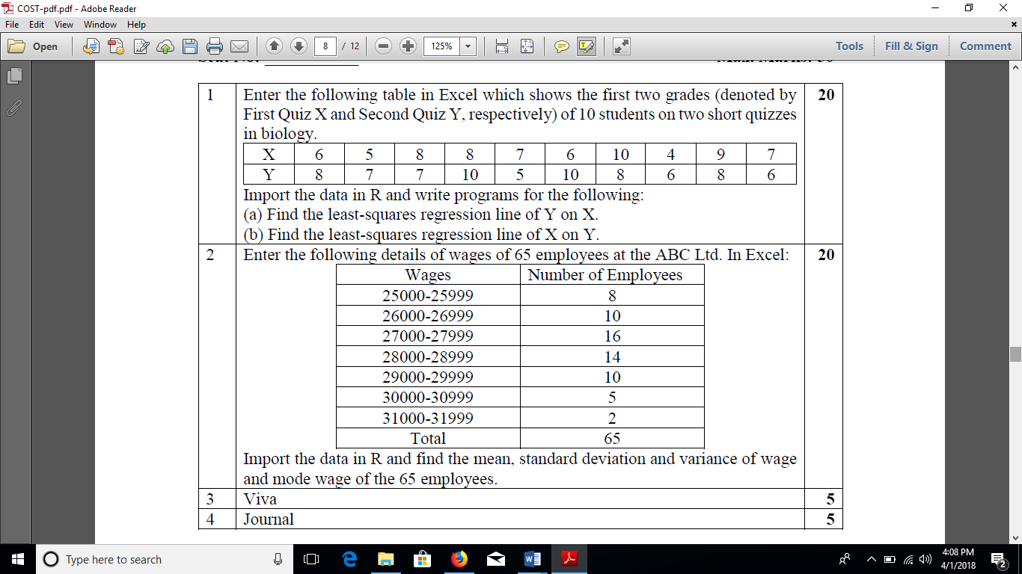

For y on x

n=10

x=c(6,5,8,8,7,6,10,4,9,7)

y=c(8,7,7,10,5,10,8,6,8,6)

plot(y,x,main="population",col="blue")

cor(y,x)

fit=lm(x~y)

fit

cat("\n\n")

attributes(fit)

For x on y

n=10

x=c(6,5,8,8,7,6,10,4,9,7)

y=c(8,7,7,10,5,10,8,6,8,6)

plot(x,y,main="population",col="blue")

cor(x,y)

fit=lm(y~x)

fit

cat("\n\n")

attributes(fit)

M=c(8,10,16,14,2,16,10,5,2)

Sd(m)

Var(m)

Mean(m)

Median(m)

Getmode=function(m)

Uniqv=unique(m)

Uniqv[which.max(tabulate(match(m,uniqv)))]

R=getmode(m)

Print(r**)**

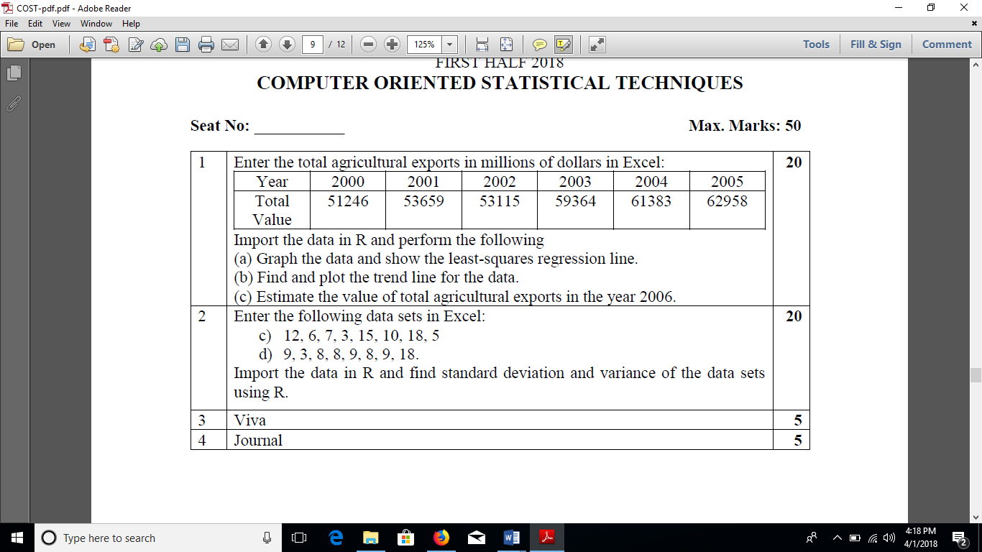

n=6

h=c(2000,2001,2002,2003,2004,2005)

w=c(51246,53659,53115,59364,61383,62958)

plot(h,w,main="population",col="blue")

cor(h,w)

fit=lm(w~h)

fit

cat("\n\n")

attributes(fit)

a=data.frame(h=2006)

r=predict(fit,a)

print (r)

png(file="trend.png")

plot(w,h,col="red",main="trend", abline(lm(w~h)),cex=1.5, pch=16,xlab="year",ylab="turnover")

dev.off()



a=mean(c(25,75,50))

print( a)

b=1/mean(1/a))

print(b)

a<-c(9,8,7,4,8,6,8,8,7,10,6,7,7,8,9,6,5,8,5,6,7,8,5,5,8,7,6,6,4,5)

n=33

xbar=mean(a)

xbar

pm=5

b=sd(a)

z=((xbar-pm)/(b-sqrt(n)))

z

alpha=0.05

z.half.alpha=qt(1-alpha/2,df=n-1)

c(-z.half.alpha,z.half.alpha)

z.alpha=qnorm(1-alpha)

z.alpha

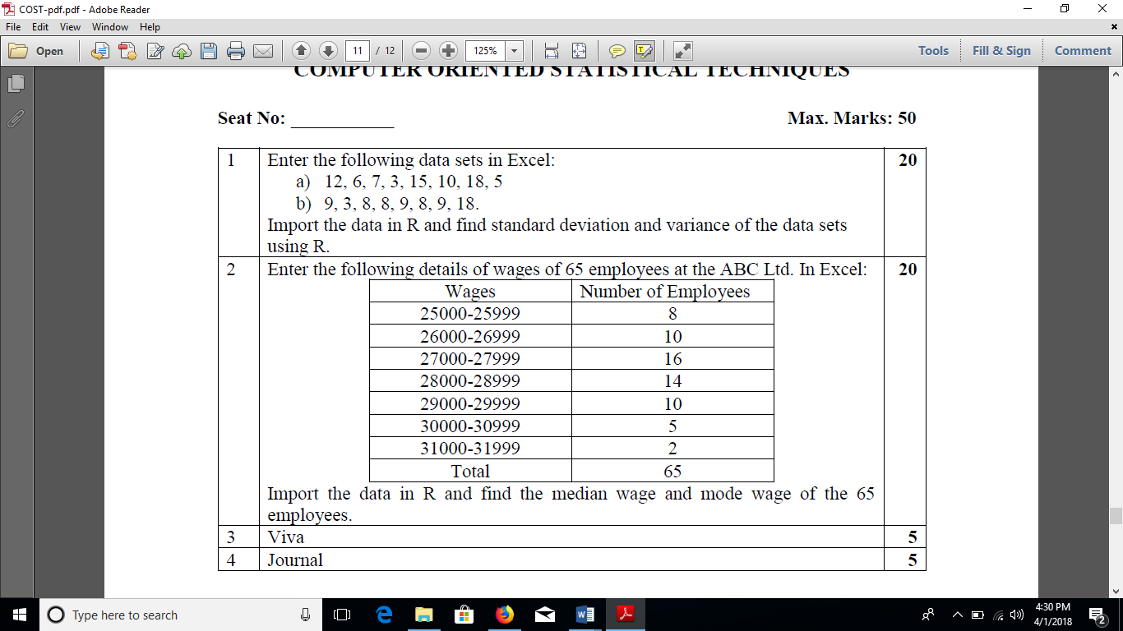

M=c(8,10,16,14,2,16,10,5,2)

Mean(m)

Median(m)

Getmode=function(m)

Uniqv=unique(m)

Uniqv[which.max(tabulate(match(m,uniqv)))]

R=getmode(m)

Print(r**)**

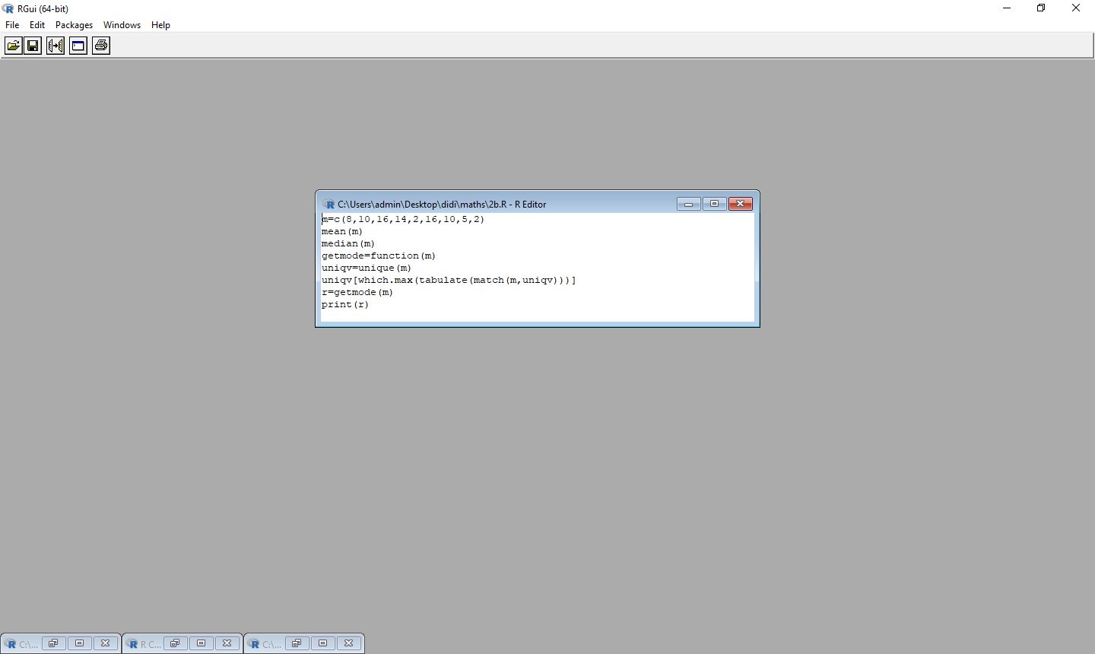







For x on y

n=10

x=c(6,5,8,8,7,6,10,4,9,7)

y=c(8,7,7,10,5,10,8,6,8,6)

plot(x,y,main="population",col="blue")

cor(x,y)

fit=lm(y~x)

fit

cat("\n\n")

attributes(fit)

S=c(2,38,5,8)

D=c(data of distributed)

c.data<-data.frame(s,d)

c.data=table(s,d)

print(c.data)

print(chisq.test(c.data))